Analyzing Life Cycle Models for Sustainable Development
Tyler Daniels
Southern New Hampshire University
CS-600
Professor Kardell
10-18-26

Analyzing Life Cycle Models for Sustainable Development
For this research application, I chose an iterative Agile software development life cycle supported by DevSecOps practices. The system needs to provide a secure visual interface, manage several hundred million records, and support CRUD operations, regular expression searches, and scheduled reports. These requirements involve enough complexity that I would want the team to build and evaluate the application in manageable increments. Agile provides opportunities to gather feedback throughout development, while DevSecOps brings security, testing, and operational concerns into that ongoing work.
My diagram begins with requirements and a prioritized backlog, followed by architecture and security design. These stages establish what the application must accomplish and how the team will address its most significant risks. For example, CRUD requirements need rules about who can create, view, modify, or delete research records. Search requirements need to define acceptable response times and limits on user-provided regular expressions. Scheduled reports need clear expectations for their content, timing, and handling of failures. Defining these expectations early gives developers and stakeholders a shared basis for evaluating each increment.
The architecture stage is especially important because of the amount of data the application will store. The diagram includes database indexing, partitioning, authentication, authorization, encryption, and background report scheduling. I would use this stage to evaluate design choices before committing to a complete implementation. Early prototypes and performance tests could help determine whether the proposed database structure and search approach can meet the agreed targets. Agile development still requires this planning, particularly when decisions could affect the security and performance of the entire system.
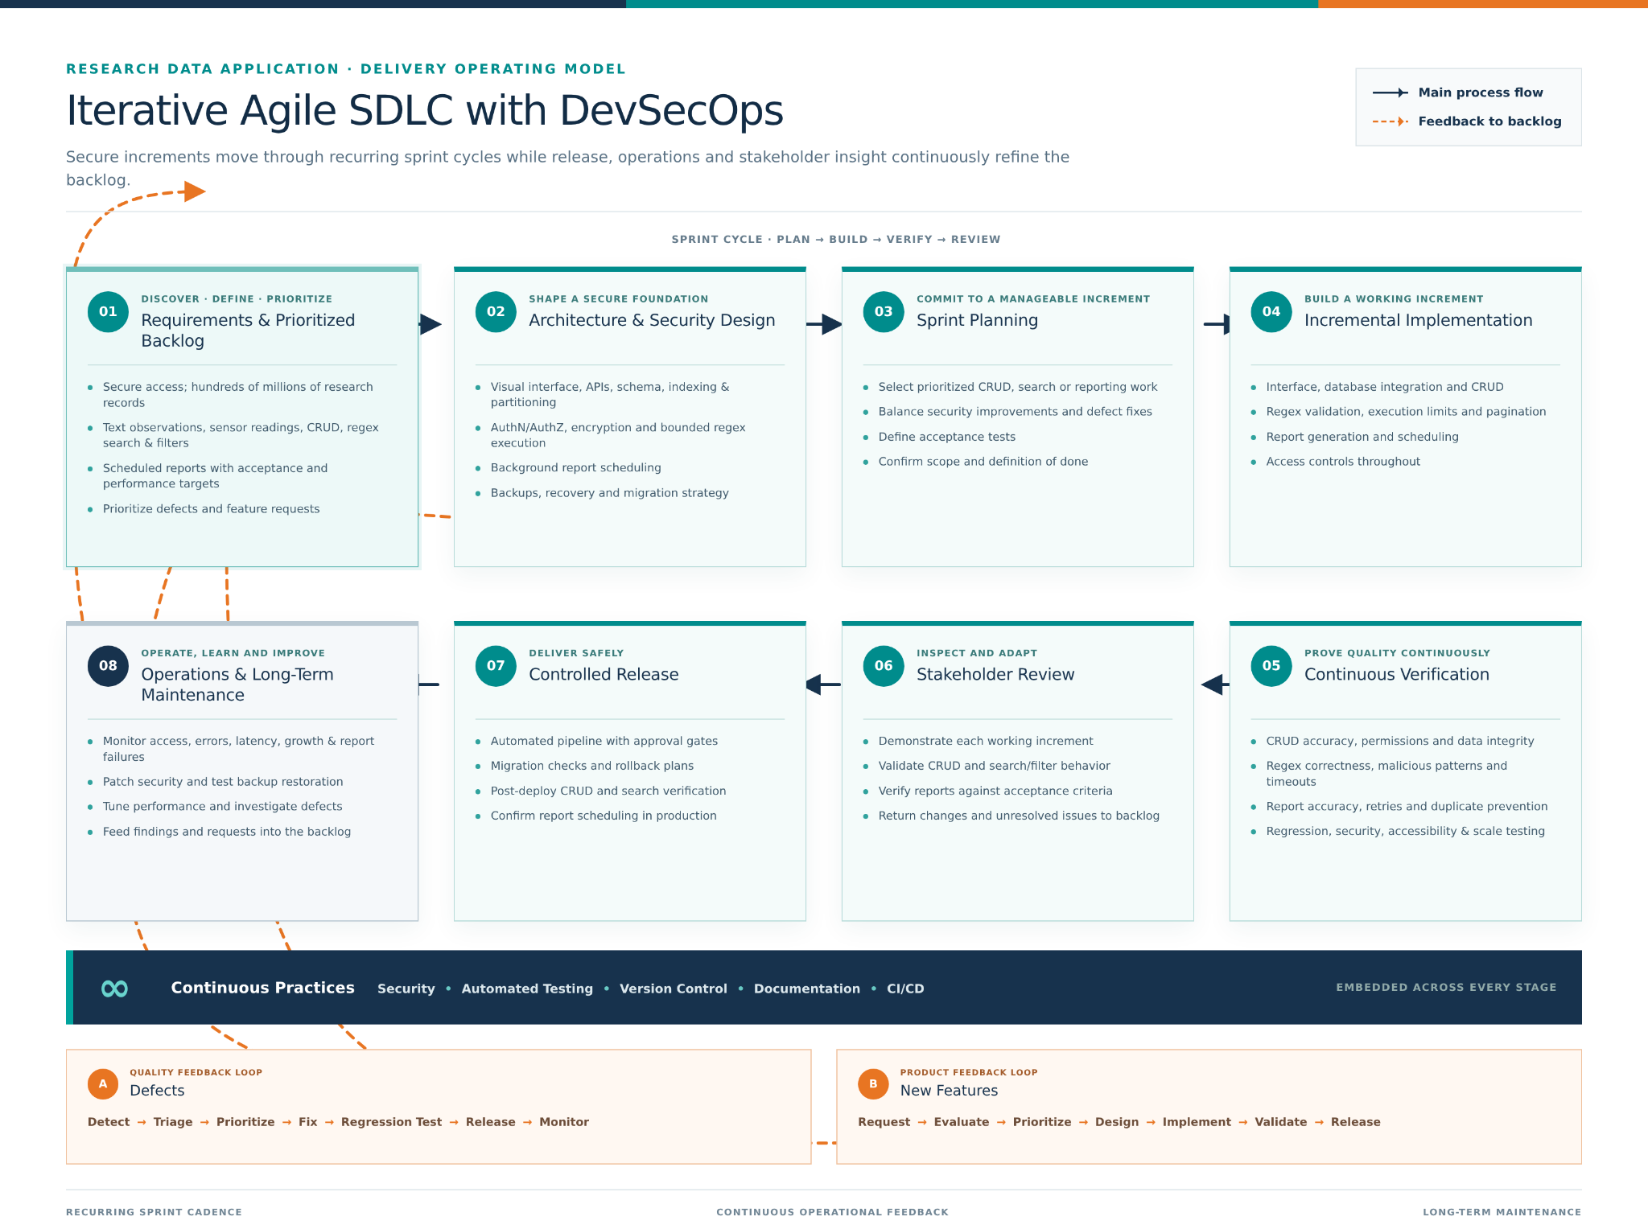
The middle stages of the diagram show how the team would move from sprint planning through implementation, continuous verification, and stakeholder review. An early increment could provide secure access and basic record creation and retrieval. Later increments could add editing, deletion, regex filtering, and scheduled reporting. Each increment would include acceptance criteria and relevant tests. CRUD testing would check permissions and data integrity. Regex testing would check valid searches, invalid patterns, and execution limits. Report testing would examine accuracy, scheduling, retries, and prevention of duplicate execution. Stakeholder review would then help confirm that these capabilities support the researchers’ actual workflows.
This process supports short-term progress by giving the team a defined set of priorities for each sprint. It also supports long-term maintenance through the controlled release and operations stages. The diagram includes migration checks, rollback plans, monitoring, security patches, and backup restoration tests. These activities matter because a successful first release does not guarantee that the application will continue to perform well as its database grows. Operational findings return to the backlog so that performance tuning, reliability improvements, and maintenance receive attention alongside new functionality.
The defect feedback loop shows how problems would be handled throughout the application’s life. A defect would be detected, assessed, prioritized, corrected, regression tested, released, and monitored. Priority would depend on its impact. An authorization problem exposing research records would require more urgent attention than a minor display issue. Adding a regression test after a correction would help the team detect the same problem if a later change reintroduced it. Monitoring after release would provide further evidence that the correction worked under actual operating conditions.
The new feature feedback loop provides a similar structure for changes requested by stakeholders. Requests would be evaluated for their value, effort, security implications, and effect on existing functionality before being prioritized. For example, researchers might request a new report format or an additional sensor data field. The team would consider the effects on the interface, database, searches, and existing reports before implementation. This allows the application to evolve while keeping changes visible and manageable.
Compared with a traditional waterfall process, this approach provides more frequent opportunities to evaluate working software and revise priorities. Waterfall could offer a clear sequence of documented phases when requirements are stable. However, this project contains uncertainties about search performance, data growth, and reporting needs that may become clearer through use. Iterative development allows the team to investigate those uncertainties earlier and adjust subsequent work. It still requires documentation and disciplined planning to prevent frequent changes from creating inconsistent designs.
In a professional setting, the main benefits would be earlier feedback, smaller releases, and shared responsibility for security and reliability. The challenges would include maintaining automated tests, coordinating stakeholder participation, and providing realistic environments for large-scale performance testing. The team would also need to reserve time for maintenance so that feature requests do not continually displace it. Developing this diagram helped me see the life cycle as an ongoing process of delivery, evaluation, and improvement. In future projects, I would use that perspective to plan for both the initial application and the work needed to keep it dependable after release.

